Line Chaser, Different Creatures, a Single Goal.

Kyle Gustafson

**KEY** **WORDS**

Randomly generated art, hunt, resource, unity, individuality, cooperation, death, rebirth, difficulty.

**INTRODUCTION**

This paper serves to represent the line chaser, a generative art app that follows three unique creatures as the hunt for food. Each create has a unique shape, a unique color and a unique skill set.

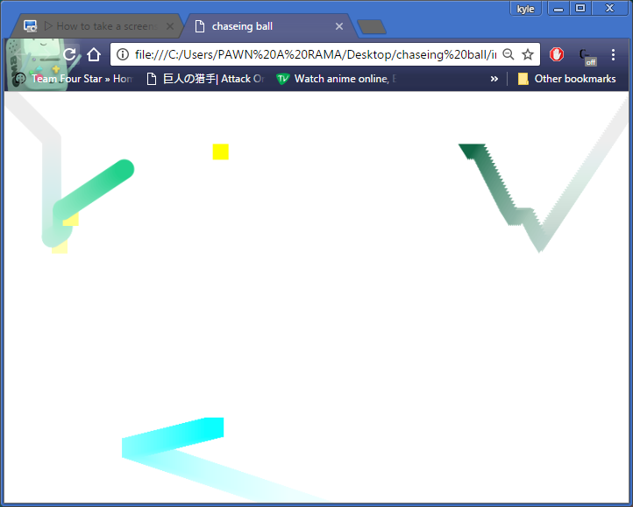

**THE PURPOSE**

This program was created as a randomly generating art piece first and foremost. However over time ideas and codes were expanded on and repurposed. A tool to set positions became a target to hunt. A set off identical balls gained individuality and uniqueness. The possibility of death was give to the creatures.

**THE CREATURES**

There are three unique creatures that spawn in set locations on the map; a circle that starts in the top left, a triangle the stars in the top right, and a square that starts in the bottom center.

Each shape is assigned a random color at the start of each iteration of the program. There is only one goal for the creatures, get to the food. Without the meal the creatures will fade and die. in order to achieve their goal off getting food in their time limit each creature is given a spread of 10 stat point that improve their up, down, left, right, movement speed. The circle is balanced and has an even 3,2,3,2 stat spread. The triangle favors verticality and thus has a 1,2,3,4 spread to optimize it up/down speed. The square has the opposite preference and therefore has a 4,3,2,1 spread to maximize it horizontal performance.

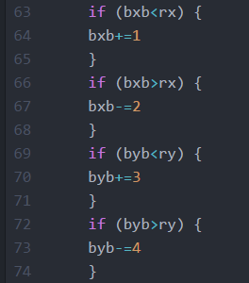

**UNITY**

Though each creature is a unique individual they still operate as a unit. In their shape, size, color, stats, even in starvation they are all meant to be relativistic to each other if not truly equal. Although each shape is different the overall size of each unit is based on 25 pixels. Also despite being different colors each color is created from the same rgb color randomizer. The circle simply receives whichever values the rgb randomizer generates but the triangle receives the values over two and the rectangle receives twice the random values.

By giving each character a set of 10 stat points a giving them separate spreads each character is able to have strengths without being significantly better then it teammates. This also allows for each character to be able to compensate for the weakness of it team. Finally to solidify their unity each character is life linked, if one dies they all die. To compensate for this the shapes draw from a shared pool of food, this means that when one grabs the food block the total amount of food is increased for each character evenly.

**DEATH, DIFFICULTY, AND REBIRTH.**

The shapes start off with a shared pool off 300 foods, if any shape collects the food, the pool resets to 300, if the pool reaches 0 the is no food for anyone to draw from so they all die, this death is noted by a fading opacity and an eventual empty screen. The world of these creatures is set to the size of the canvas so on a canvas of a small enough size creatures will never die. Conversely on a large enough canvas death virtually guaranteed. In the case of death a new set of creatures will eventually migrate onto the canvas and the cycle will repeat. This difficulty based on canvas size allows the project to be viewed in two ways. On a large canvas the piece is about a struggle to stay alive and work together. However on a small canvas where death is not possible the piece becomes an art piece about movement, lines, and merging colors



**THE CODE**

X++. That’s the workhorse of this of this assignment. By placing variations of x++ in conditional statements all of the characters movement was achieved. Simple x and y math ,that sends the characters toward their food, provides all of the codes functionality except for the randomizer that spawns and response the food. The only other bits of code worth mention are the floor on the foods x and y variables that keeps it from spawning in a location between points where the creatures cannot get to it, and the statement that sends the food off screen if the creatures die.

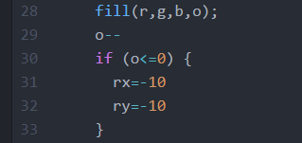

Here o is opacity and rx and ry are position variables for the food